Fast**National University of Computer & Emerging Sciences, Karachi  
Spring-2021 CS-Department  
MidTerm 1  
6th April 2021, 01:00 - 02:00 noon**

|  |  |  |
| --- | --- | --- |
| **Course Code: CS301** | **Course Name: Theory of Automata** | |
| **Instructor Names: Mr. Shahzad, Shaharbano, Bakhtawar, Musawar** | | |
| **Student Roll No:** | | **Section No:** |

Instructions:

* Return the question paper.
* Read each question completely before answering it. There are 5 **questions and 2 pages**.
* In case of any ambiguity, you may make assumption. But your assumption should not contradict any statement in the question paper.
* Start each question in a new sheet.

**Time**: 60 minutes. **Max Marks:** 55 points

**Question 1: (5+5) Points**

**A most common exam example for the finite automation can be related to the traffic lights. The traffic lights have three states namely red, yellow and green. Here the light starts from the red signal, then it comes to yellow and then finally it moves to green. There are two transitions from one state either it would remain at same state or it would move to different state, but it should follow the sequence. Design a DFA and transition table for the above problem, identify initial and final states.**

**Question 2: (DFA) (5+3+5) Points**

1. **Find the DFA for the language L of string which contain the substring abb but not bbb and aaa and ends with aa.**
2. **Construct the FA for the following regular expression.(0+1)*111+(0+1)*001**
3. **Find the DFA for the language L of string which contain the substring aa or ab.**

**Question 3: (Regular Expressions) 12 Points**

**Express each of these languages over Σ = {0, 1} using a regular expression.**

**a)**      **L1= {anbm: n ≥ 4,m ≤ 3}.**

**b)**     **L2= {anbm: n < 4,m ≤ 3}.**

**c)**      **The complement of L1.**

**d)**     **The complement of L2.**

**e)**      **The set of strings upon S={0,1}, of one or more 0s followed by a 1**

**f)**       **The set of strings with either no 1 preceding a 0 or no 0 preceding a 1**

**Question 4: (Conversion epsilon-NFA to DFA) 10 Points**

**Construct the DFA from the Epsilon NFA given in figure 1.**

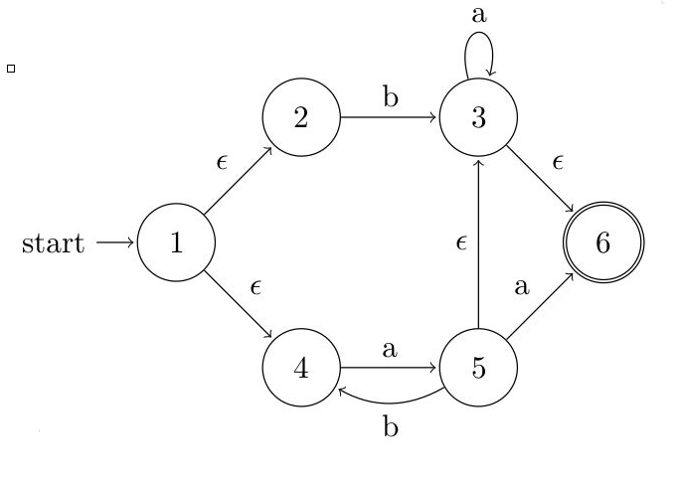

Figure 1

**Note: Show steps of your method properly to get full credit.**

**Question 5: (GTG and State Elimination) 10 Points**

**Find the regular expression of the DFA given in figure 2, using state elimination method.**

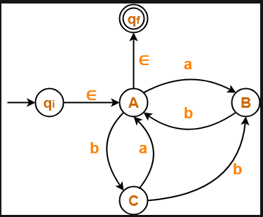

Figure 2

**Note: Show steps of your method properly to get full credit.**

***BEST OF LUCK!***